**KUBERNETED DOCUMENT**

**First creating persistent volume and storing in pv.yaml file**

**Volume Configuration:**

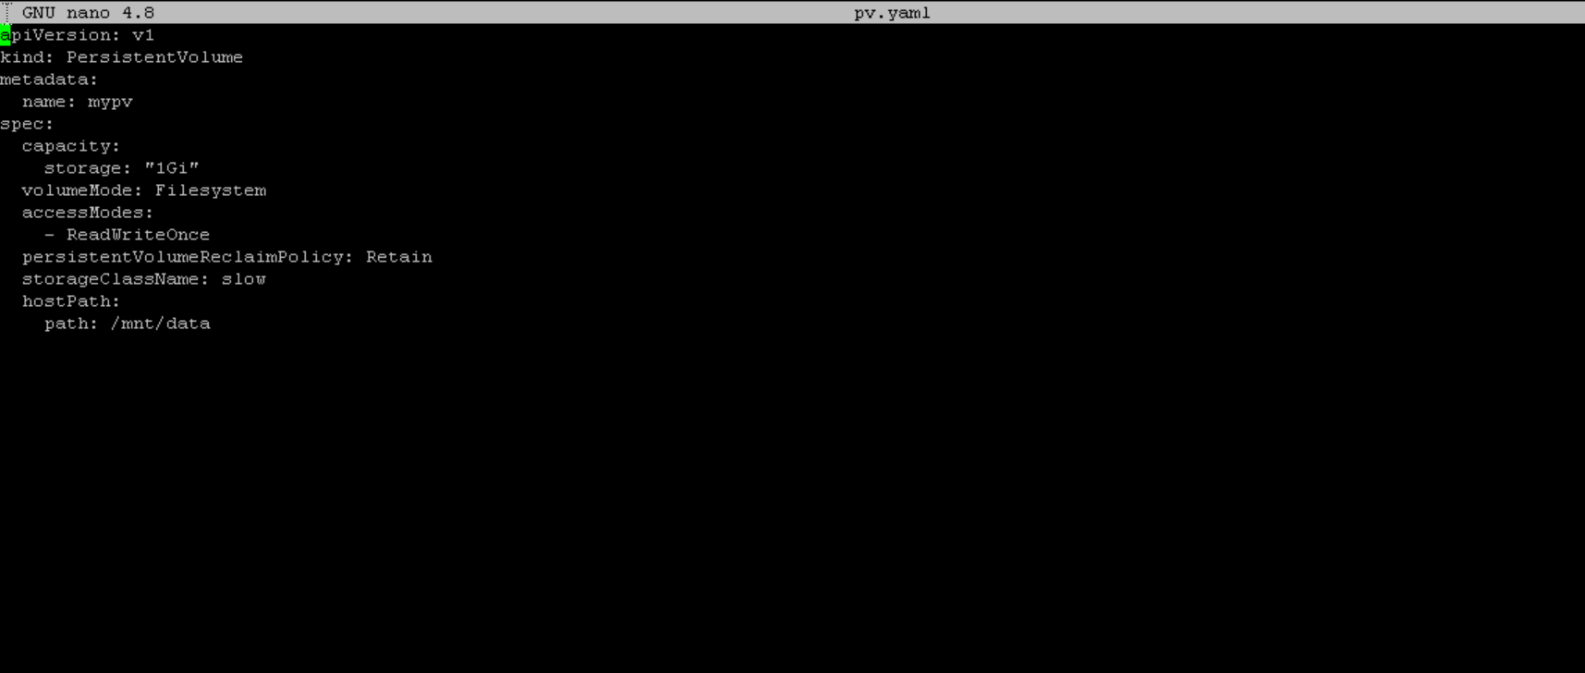

**Creating PVC :**

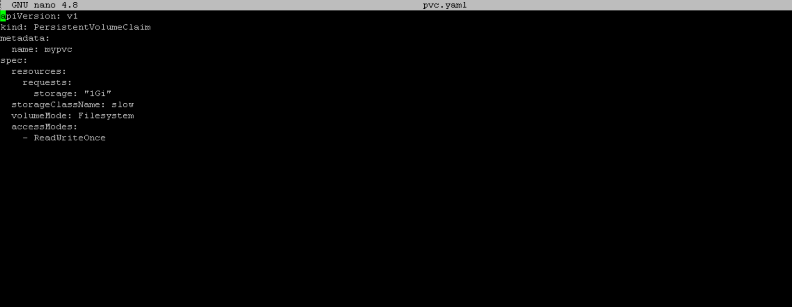

**Then applying both the files**



**Pod configuration:**

**YAML configuration for nginx-pod**

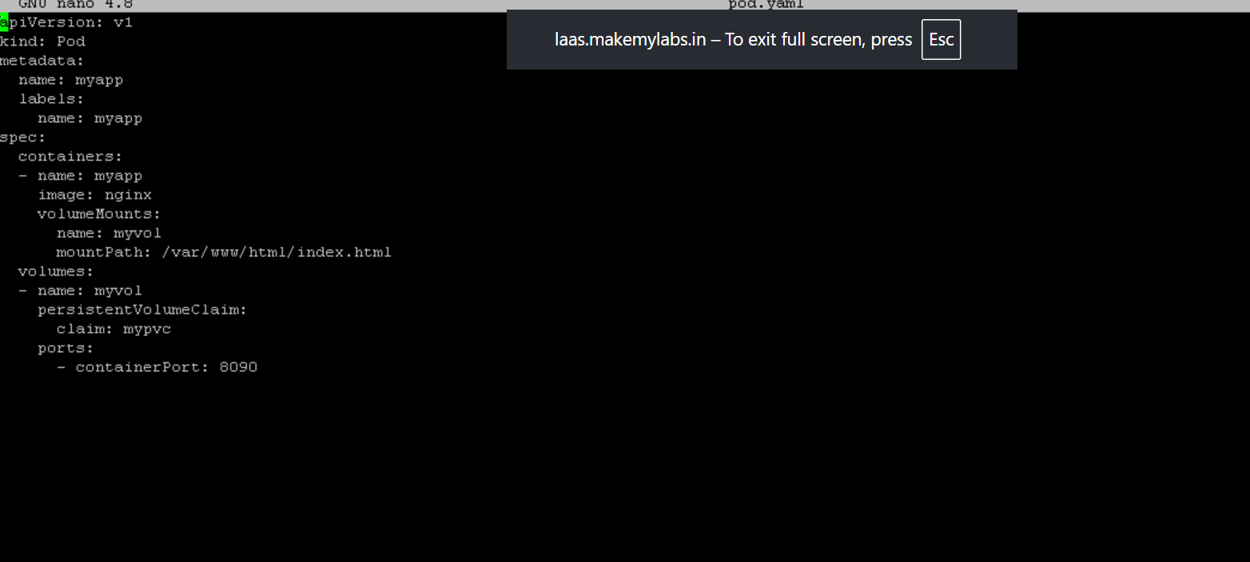

**Apply the configuration file**



**Verifying the pods**

